SalesKik Onboarding - Conversational Full Breakdown with Visuals

Overview
Think of the SalesKik Onboarding section as your private command center. This is not just a dashboard—it's the mission control for the entire SalesKik business. It’s where the SalesKik team can see, guide, and support every customer from the moment they show interest all the way to becoming fully active and successful users. What makes this different from other parts of the platform is that this is strictly internal. No customer will ever see this side. It’s where we track their onboarding journey, monitor their engagement, handle their billing, respond to issues, and keep an eye on their overall health.

Lead & Trial Intake
Let’s break down what 'Lead & Trial Intake' actually means in practice:
- Automatically capture leads and trial requests from all sales channels (website forms, partner referrals, marketing campaigns).
- Auto-tag leads with source information and assign to a dedicated onboarding specialist.
- Generate immediate welcome emails with links to initial setup resources.
This is like the welcome mat for every potential customer. We’re not just capturing their name and email—we’re also noting where they came from, whether that’s a Facebook ad, a referral partner, or our website’s signup page. We can automatically assign them to the right onboarding team member and make sure they get an instant welcome email with links to start exploring.
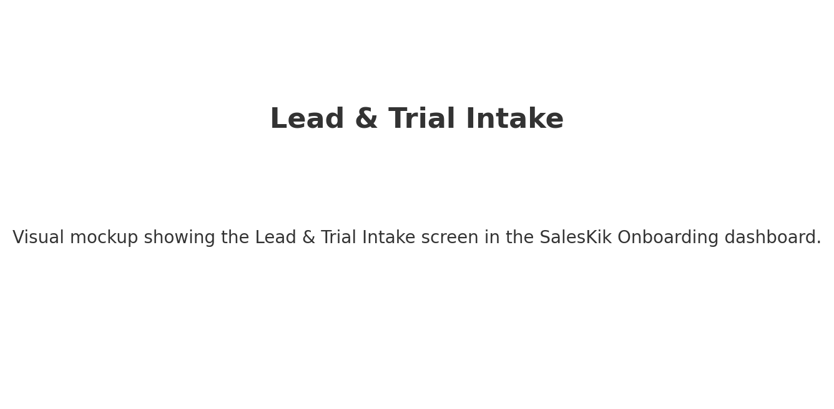
What you’re seeing in the visual above for 'Lead & Trial Intake':
This mockup shows a possible layout for the Lead & Trial Intake screen. It would have key metrics at the top, actionable items in the middle, and filtering tools to quickly find relevant data. The idea is to make it simple for the SalesKik team to understand the status and take action immediately.

Account Provisioning
Let’s break down what 'Account Provisioning' actually means in practice:
- Set up the new tenant environment with selected modules based on the customer’s industry or package.
- Apply correct regional and currency settings for accurate tax handling.
- Enable any pre-purchased add-ons and upload initial branding assets.
Once a customer signs up, we spin up their own dedicated space within SalesKik. This is where we set all the defaults for their account—currency, tax settings, modules enabled—and even upload their branding so their end users see a familiar look and feel right from the start.
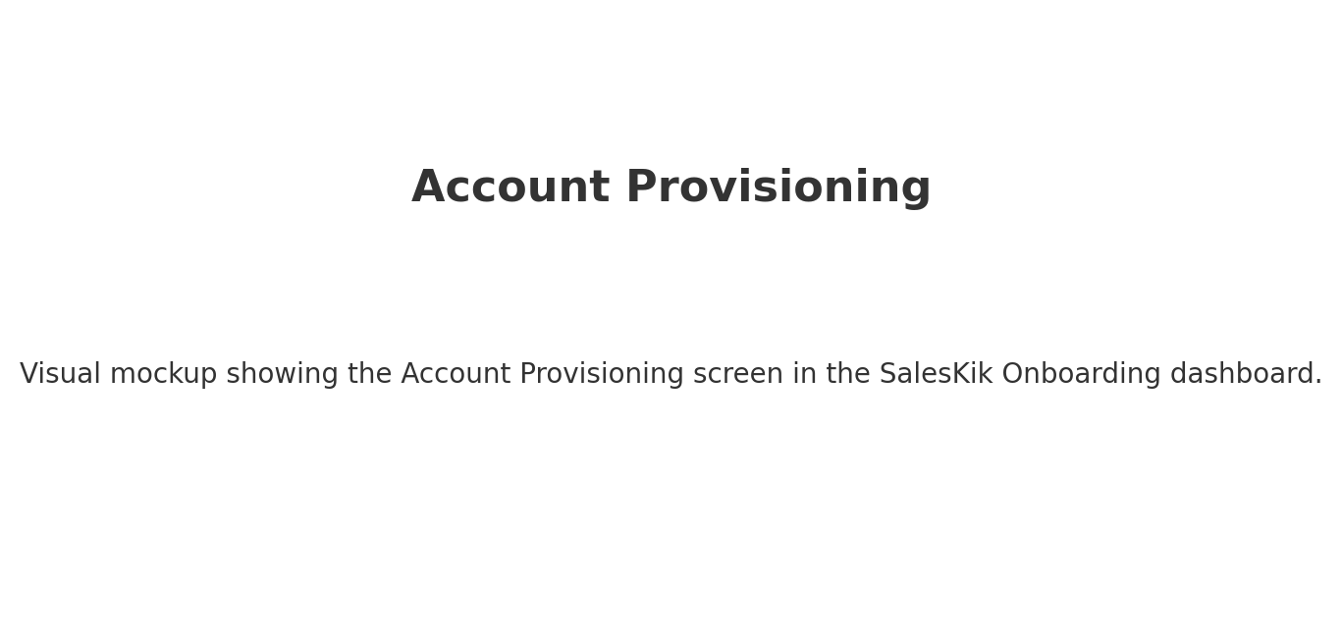
What you’re seeing in the visual above for 'Account Provisioning':
This mockup shows a possible layout for the Account Provisioning screen. It would have key metrics at the top, actionable items in the middle, and filtering tools to quickly find relevant data. The idea is to make it simple for the SalesKik team to understand the status and take action immediately.

Onboarding Workflow
Let’s break down what 'Onboarding Workflow' actually means in practice:
- Customizable checklist tracking each milestone (first login, catalogue upload, first quote/order).
- Highlight stalled steps with automatic alerts to onboarding staff.
- Integrate guided tours and tutorials directly into the customer's workspace.
Think of this as the customer’s personal to-do list for getting fully set up. It’s a checklist of important milestones—like uploading their first product, creating their first quote—and it shows us exactly where they’re moving quickly and where they might be stuck.
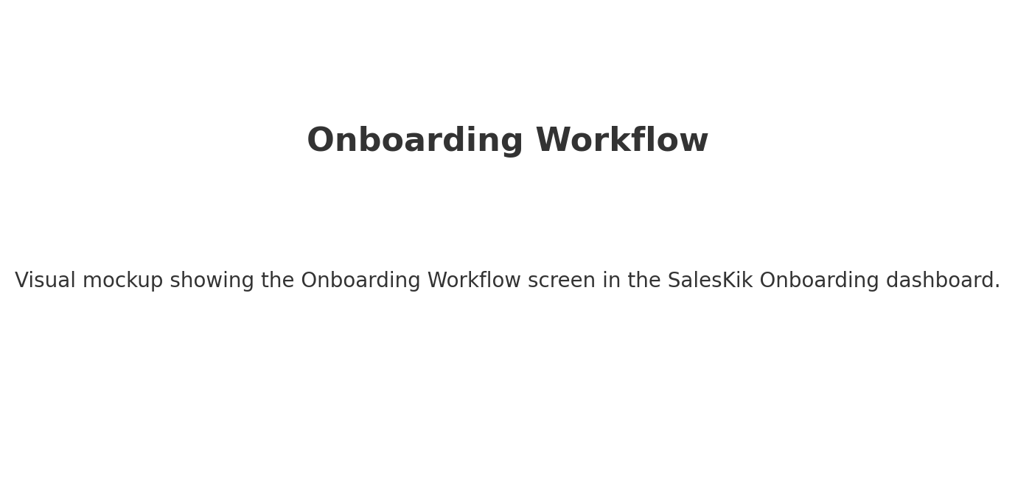
What you’re seeing in the visual above for 'Onboarding Workflow':
This mockup shows a possible layout for the Onboarding Workflow screen. It would have key metrics at the top, actionable items in the middle, and filtering tools to quickly find relevant data. The idea is to make it simple for the SalesKik team to understand the status and take action immediately.

Customer Directory
Let’s break down what 'Customer Directory' actually means in practice:
- Central searchable directory of all customer accounts with filters for status, industry, and usage health.
- Individual profile pages summarizing activity, support tickets, and billing history.
- Highlight accounts approaching renewal or showing signs of churn risk.
This is our master list of every customer we’ve ever worked with. We can search and filter by almost anything—industry, account health, or activity level—and click into a profile to see their entire history with us.
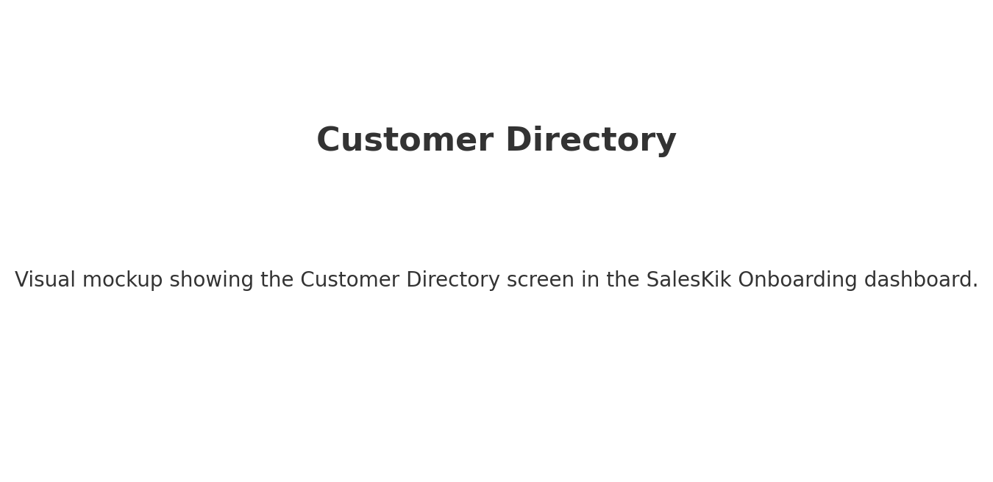
What you’re seeing in the visual above for 'Customer Directory':
This mockup shows a possible layout for the Customer Directory screen. It would have key metrics at the top, actionable items in the middle, and filtering tools to quickly find relevant data. The idea is to make it simple for the SalesKik team to understand the status and take action immediately.

Usage Analytics
Let’s break down what 'Usage Analytics' actually means in practice:
- Real-time dashboards tracking feature usage, active user counts, and engagement frequency.
- Identify high-performing accounts and accounts with low adoption.
- Segment analytics by customer size, industry, or plan type.
Here we can see exactly how customers are using SalesKik—what features they love, what they ignore, and how often they log in. It’s the pulse of the customer base.
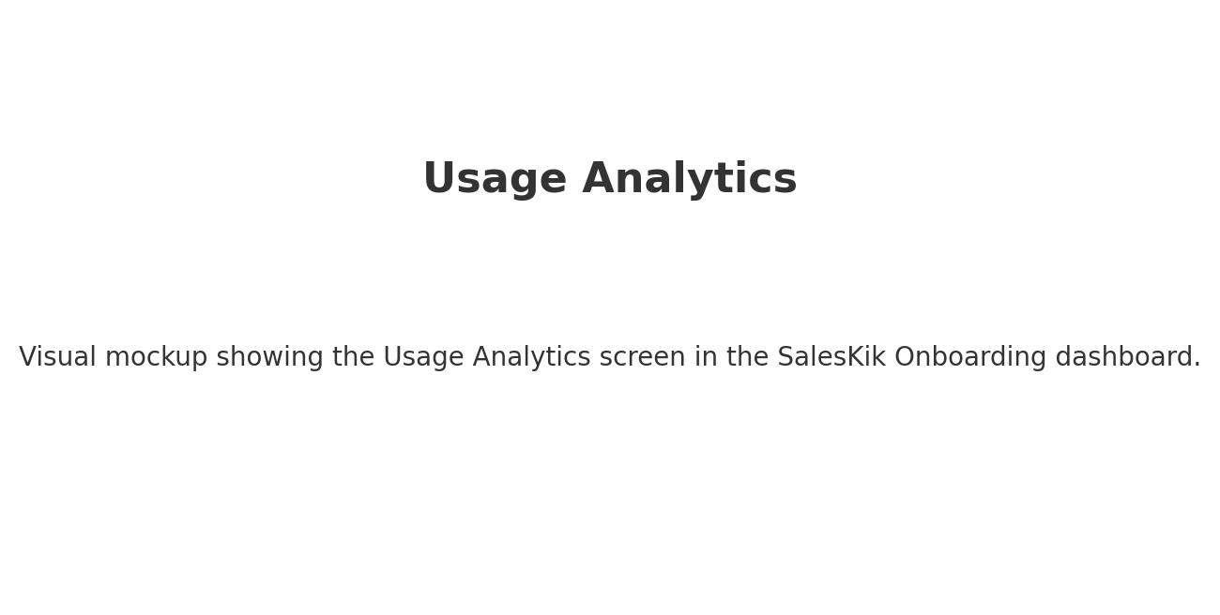
What you’re seeing in the visual above for 'Usage Analytics':
This mockup shows a possible layout for the Usage Analytics screen. It would have key metrics at the top, actionable items in the middle, and filtering tools to quickly find relevant data. The idea is to make it simple for the SalesKik team to understand the status and take action immediately.

Billing & Subscriptions
Let’s break down what 'Billing & Subscriptions' actually means in practice:
- Full visibility of active subscriptions, plan levels, and add-ons per account.
- Generate invoices and track payment statuses with automated dunning for overdue balances.
- Support for discounts, promotional codes, and usage-based billing models.
This is the financial heartbeat of SalesKik. We can see their current plan, what add-ons they’ve purchased, and whether their payments are up to date. If something’s overdue, we can trigger reminders or escalate it.
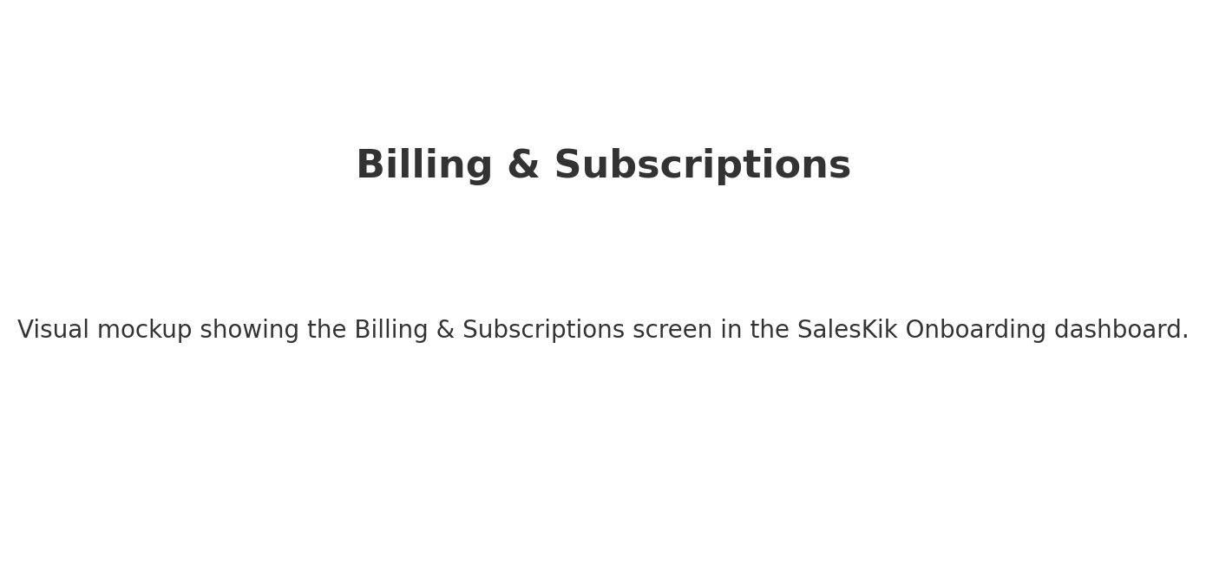
What you’re seeing in the visual above for 'Billing & Subscriptions':
This mockup shows a possible layout for the Billing & Subscriptions screen. It would have key metrics at the top, actionable items in the middle, and filtering tools to quickly find relevant data. The idea is to make it simple for the SalesKik team to understand the status and take action immediately.

Support & Communication
Let’s break down what 'Support & Communication' actually means in practice:
- Integrated ticket system to handle customer issues with SLA tracking.
- Broadcast updates or maintenance notices to specific customer groups.
- Automated onboarding email sequences triggered by customer actions.
When a customer has an issue or question, it lands here. We can track the ticket, respond directly, and even broadcast announcements or updates to all customers.
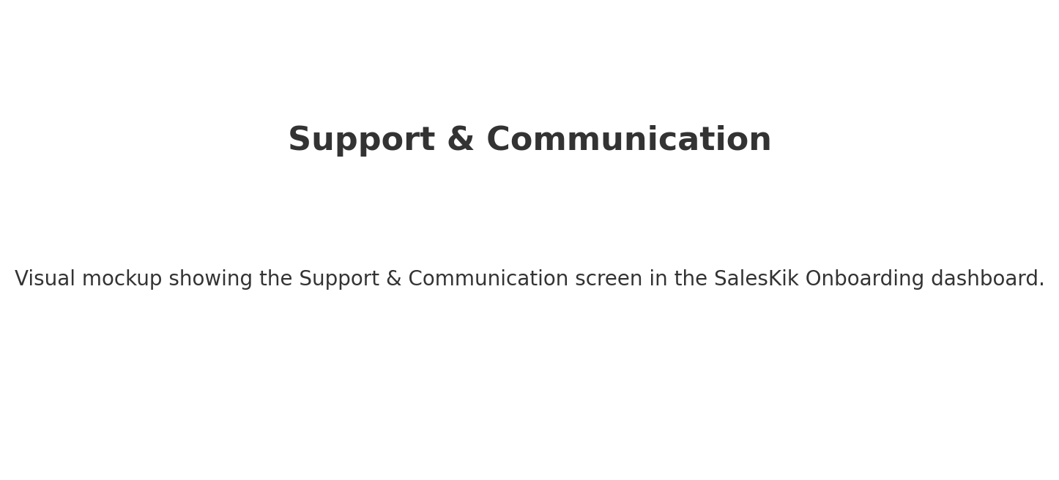
What you’re seeing in the visual above for 'Support & Communication':
This mockup shows a possible layout for the Support & Communication screen. It would have key metrics at the top, actionable items in the middle, and filtering tools to quickly find relevant data. The idea is to make it simple for the SalesKik team to understand the status and take action immediately.

Alerts & Notifications
Let’s break down what 'Alerts & Notifications' actually means in practice:
- Automated alerts for high-priority issues like sudden drops in activity or payment failures.
- Celebrate major customer milestones to strengthen engagement.
- Escalate critical issues to managers automatically.
This is our early warning system. If a customer suddenly stops logging in, or if a payment fails, we know about it right away. We can also get alerts for good news—like when they hit a milestone.
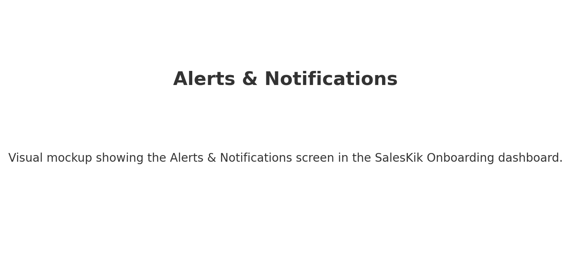
What you’re seeing in the visual above for 'Alerts & Notifications':
This mockup shows a possible layout for the Alerts & Notifications screen. It would have key metrics at the top, actionable items in the middle, and filtering tools to quickly find relevant data. The idea is to make it simple for the SalesKik team to understand the status and take action immediately.

Security & Compliance
Let’s break down what 'Security & Compliance' actually means in practice:
- Strict role-based permissions for internal staff to control data access.
- Detailed audit logs capturing every administrative action.
- Compliance features for data privacy regulations, including consent and export tools.
This keeps customer data safe and ensures we meet legal requirements. It controls who inside SalesKik can see or change different parts of the system and keeps a log of all major actions.
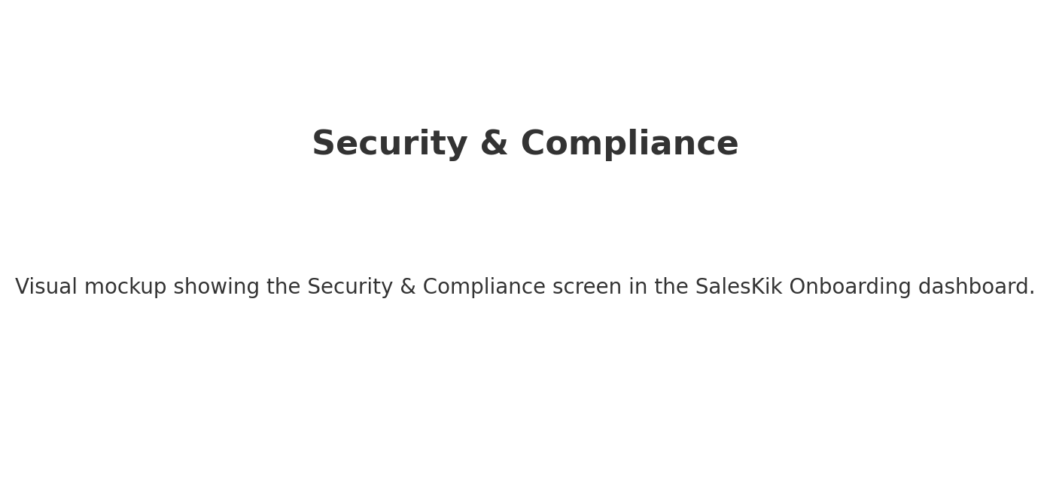
What you’re seeing in the visual above for 'Security & Compliance':
This mockup shows a possible layout for the Security & Compliance screen. It would have key metrics at the top, actionable items in the middle, and filtering tools to quickly find relevant data. The idea is to make it simple for the SalesKik team to understand the status and take action immediately.

Reporting
Let’s break down what 'Reporting' actually means in practice:
- Customizable reports covering churn rates, MRR growth, and feature adoption.
- Schedule automatic report delivery to managers via email.
- Export data in multiple formats (CSV, PDF, XLSX).
Here we turn all the activity and usage data into clear reports. We can track things like revenue growth, feature adoption, and customer satisfaction, and share these insights with the team.
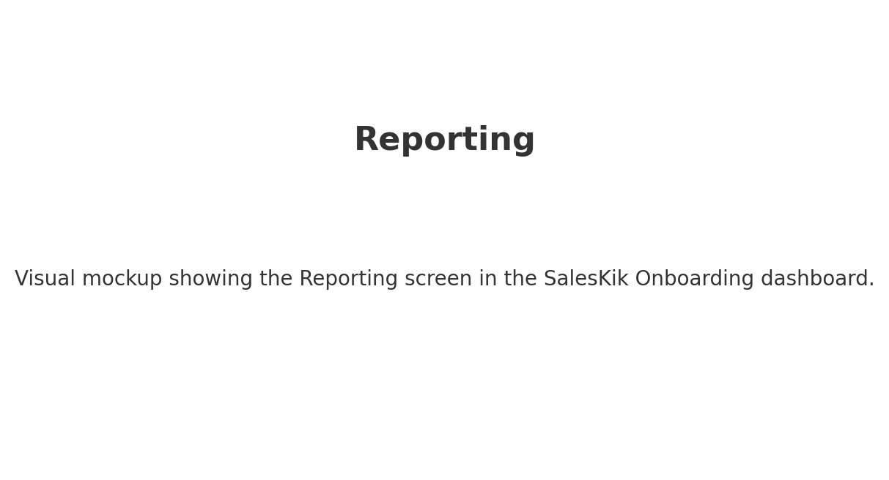
What you’re seeing in the visual above for 'Reporting':
This mockup shows a possible layout for the Reporting screen. It would have key metrics at the top, actionable items in the middle, and filtering tools to quickly find relevant data. The idea is to make it simple for the SalesKik team to understand the status and take action immediately.

